18CSC303J

HOSPITAL MANAGEMENT SYSTEMS PROJECT

**Done BY:**

**Anjlika Gupta RA1811003010345**

**CSE-F1**

**INDEX:**

* Abstract
* Introduction
* Description
* ER Diagram
* DML
* Constraints
* Operators
* Date Functions
* Character and Numeric Functions
* Group Functions
* Set Operations
* Join Operations
* Subqueries
* Pl/SQL Control Structure, Functions, Iteration
* Pl/SQL Trigger and Cursor
* Pl/SQL Views
* Pl/SQL Exception Handling

**ABSTRACT:**

The project focuses on Hospital Management System. Any well-structured database has various entities to be considered. Considering all the entities of interest, their respective attributes, database schemas were modeled and further proceedings, the different anomalies occurring were eliminated thereby improving the overall design and making it redundant free. All the design issues were considered during the database design, and while applying the queries and they were eliminated to achieve a good database design.

**INTRODUCTION:**

In today's technological world, everything is getting digitalized, almost everything and all the data is made easily accessible from anywhere and at any time. Also, instead of keeping the records in form of hard copies becomes very difficult to manage, store and process especially when it’s in large quantities.

Hence, here in the project, we aim to develop a Database management system for the Hospital where data of all the students and faculties, their subjects being taught, along with sections and other important details are being designed here.

The project first describes the Entities being considered, their attributes, and then following with the SQL queries for the table.

**DESCRIPTION:**

**Patient Table:**

|  |  |  |
| --- | --- | --- |
| **Fields** | **Data Type** | **Relationships** |
| Pid | Varchar(5) | Primary Key |
| name | Varchar(20) | Not Null |
| age | int | Not Null |
| weight | int | Not Null |
| gender | Varchar(10) | Not null |
| address | Varchar(50) | Not Null |
| phoneno | int | Not Null |
| disease | Varchar(20) | Not Null |
| doctorid | Varchar(5) | Not Null |

**Doctor Table:**

|  |  |  |
| --- | --- | --- |
| **Fields** | **Data Type** | **Relationships** |
| doctorid | Varchar(5) | Primary Key |
| doctorname | Varchar(15) | Not Null |
| dept | Varchar(15) | Not  Null |

**Lab Table:**

|  |  |  |
| --- | --- | --- |
| **Fields** | **Data Type** | **Relationships** |
| labno | Varchar(5) | Primary Key |
| pid | Varchar(5) | Not Null |
| weight | int | Not Null |
| doctorid | Varchar(5) | Foreign Key |
| date | Date/Time | Not Null |
| category | Varchar(15) | Not Null |
| patient_type | Varchar(15) | Not Null |
| amount | int | Not Null |

**Inpatient Table:**

|  |  |  |
| --- | --- | --- |
| **Fields** | **Data Type** | **Relationships** |
| pid | Varchar(5) | Primary Key |
| room_no | Varchar(50) | Not Null |
| date_of_adm | Date/Time | Not Null |
| date_of_dis | Date/Time | Not Null |
| advance | int | Not Null |
| labno | Varchar(5) | Foreign Key |

**Outpatient Table:**

|  |  |  |
| --- | --- | --- |
| **Fields** | **Data Type** | **Relationships** |
| pid | Varchar(5) | Primary Key |
| date | Date/Time | Not Null |
| labno | Varchar(5) | Foreign Key |

**Room Table:**

|  |  |  |
| --- | --- | --- |
| **Fields** | **Data Type** | **Relationships** |
| room_no | Varchar(50) | Primary Key |
| room_type | Varchar(10) | Not Null |
| status | Varchar(10) | Not Null |

**Bill Table:**

|  |  |  |
| --- | --- | --- |
| **Fields** | **Data Type** | **Relationships** |
| bill_no | Varchar(50) | Primary Key |
| pid | Varchar(5) | Foreign Key |
| patient_type | Varchar(10) | Allow Null |
| doctor_charge | int | Not Null |
| medicine_charge | int | Not Null |
| room_charge | int | Not Null |
| oprtn_charge | int | Allow Null |
| no_of_days | int | Allow Null |
| nursing_charge | int | Allow Null |
| Advance | int | Allow Null |
| health_card | Varchar(50) | Allow Null |
| lab_charge | int | Allow Null |
| Bill | int | Not Null |

**ER Diagram:**

An entity-relationship diagram is used in modern database software engineering to illustrate the logical structure of the database. It is a relational schema database modeling method used to model a system and approach. This approach commonly used in database design. The diagram created using this method is called the E-R diagram.

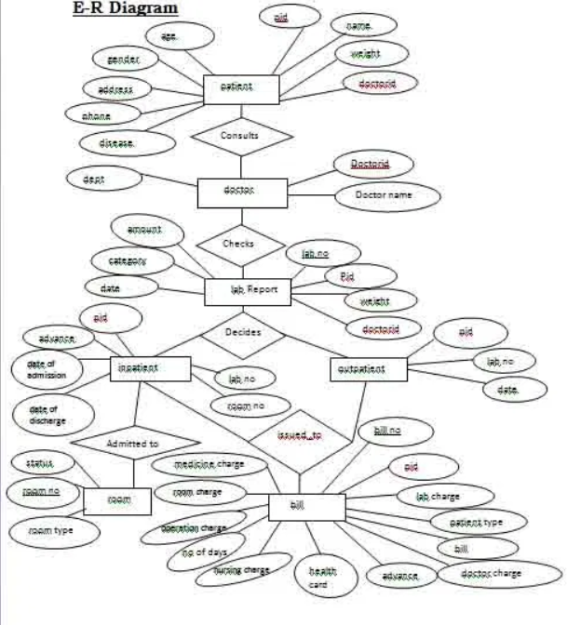

**DDL, DML, and Constraints:**

**Patient Table:**

CREATE TABLE PATIENT(PID varchar(5) NOT NULL PRIMARY KEY,NAME varchar(20) NOT NULL,AGE INT NOT NULL,WEIGHT INT NOT NULL,GENDER varchar(50) NOT NULL,ADDRESS varchar(50) NOT NULL,PHONENO INT NOT NULL,DISEASE VARCHAR(20) NOT NULL, DOCTORID VARCHAR(5) NOT NULL);

INSERT INTO PATIENT VALUES('P2','AMAYA',28,50,'FEMALE','P123MAINROAD',8954356434,'VIRAL FEVER','D2');

INSERT INTO PATIENT VALUES('P3','SAHIL',53,75,'MALE','BTM',9165095784,'VIRAL FEVER','D2');

INSERT INTO PATIENT VALUES('P4','SAMARTH',15,35,'MALE','J212',8171507245,'TYPHOID','D3');

INSERT INTO PATIENT VALUES('P5','SHARAN',29,65,'MALE','T12',9412964465,'BODYACHE','D4');

INSERT INTO PATIENT VALUES('P6','ANANYA',59,48,'FEMALE','ESTANCIA',8194034567,'MALARIA','D5');

INSERT INTO PATIENT VALUES('P7','MANSI',34,56,'FEMALE','ABODEVALLEY',9410586268,'DIABETES','D6');

INSERT INTO PATIENT VALUES('P8','MANAN',20,63,'MALE','ESTANCIA',8194032998,'COLD','D1');

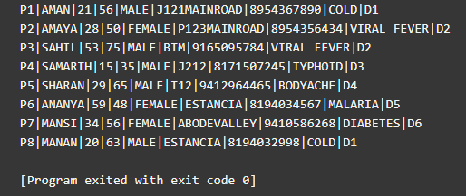

**Doctor Table:**

**Lab Table:**

**Create table Lab(labno varchar(15),pid varchar(15) NOT NULL,weight int NOT NULL,doctorid varchar(15) NOT NULL,dt date NOT NULL,category varchar(15) NOT NULL,ptype varchar(15) NOT NULL,amount int NOT NULL,PRIMARY KEY (labno));**

**INSERT INTO Lab VALUES('L01','P2',50,'D2','17-Dec-19','VIRAL FEVER','SR7',500);**

**INSERT INTO Lab VALUES('L01','P3',75,'D2','20-Feb-20','VIRAL FEVER','SR7',500);**

**INSERT INTO Lab VALUES('L03','P4',35,'D3','22-Feb-20','TYPHOID','BR6',1500);**

**INSERT INTO Lab VALUES('L04','P5',65,'D4','02-Apr-19','BODYACHE','WQ2',500);**

**INSERT INTO Lab VALUES('L05','P6',48,'D5','01-May-19','MALARIA','OP4',2000);**

**INSERT INTO Lab VALUES('L06','P7',56,'D6','09-Jun-19','DIABETES','YT9',4000);**

**INSERT INTO Lab VALUES('L07','P8',63,'D1','23-May-20','COLD','SR7',500)**

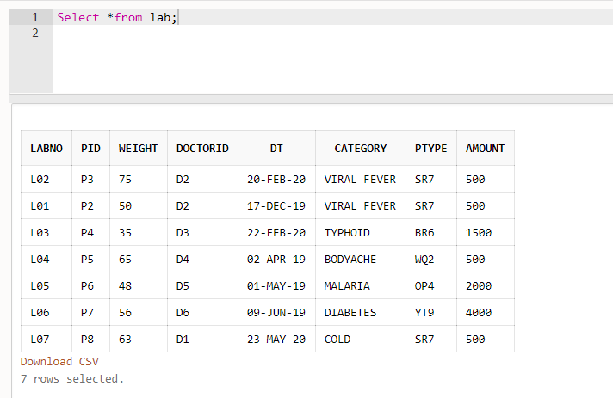

**Inpatient Table:**

CREATE TABLE INPATIENT(PID varchar(5) NOT NULL PRIMARY KEY,room_no varchar(50) NOT NULL, dt_of_adm date NOT NULL,dt_of_dis date NOT NUL,advance int NOT NULL, Labno varchar(5))

INSERT INTO INPATIENT VALUES('P2','R1',DATE '2019-12-13',DATE '2019-12-17','200', 'L01')

INSERT INTO INPATIENT VALUES('P3','R2',DATE '2020-01-30',DATE '2020-02-02','1500', 'L02')

INSERT INTO INPATIENT VALUES('P4','R3',DATE '2020-02-18',DATE '2020-02-22','1800', 'L03')

INSERT INTO INPATIENT VALUES('P5','R4',DATE '2019-04-01',DATE '2019-04-02','2200', 'L04')

INSERT INTO INPATIENT VALUES('P6','R5',DATE '2019-04-29',DATE '2019-05-01','170', 'L05')

INSERT INTO INPATIENT VALUES('P7','R6',DATE '2019-06-01',DATE '2019-06-05','1400', 'L06')

INSERT INTO INPATIENT VALUES('P8','R7',DATE '2019-05-19',DATE '2019-05-23','1900', 'L07')

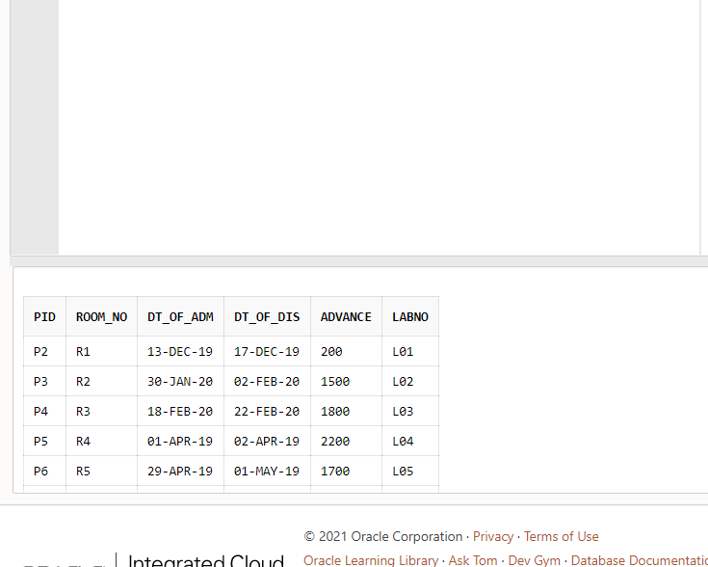

**Outpatient Table:**

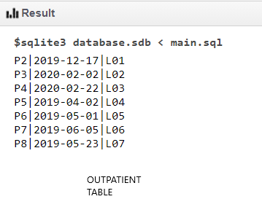

**Room Table:**

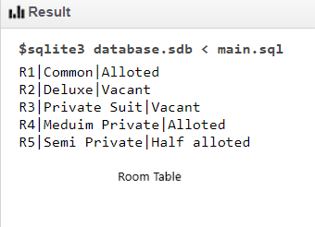

**Bill Table:**

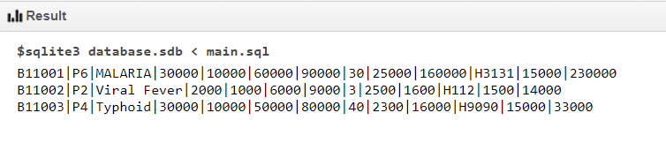

**Operators:**

1) SELECT * FROM PATIENT WHERE GENDER='MALE';

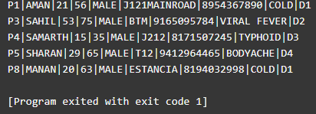

2) SELECT NAME FROM PATIENT WHERE DISEASE='VIRAL FEVER';

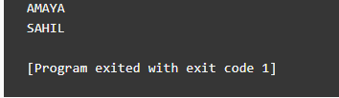

3) SELECT * FROM PATIENT WHERE NAME LIKE 'S%';

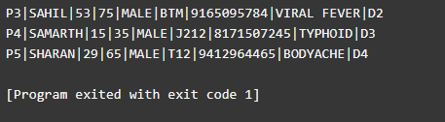

**Date Functions:**

1) Select DT From Lab Where PID = “P4”;

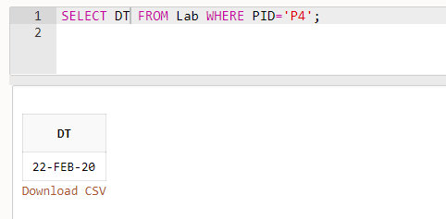

2) Select Labno,DT From Lab Where Pid=”P4”;

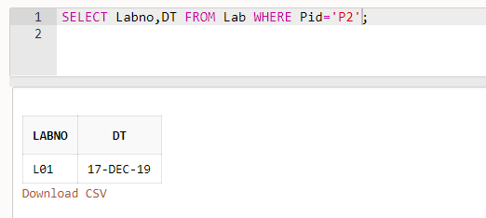

3) Select doctored,DT From Lab Where Pid= “P7”;

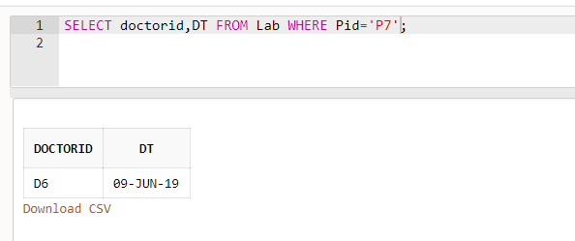

**Character and Numeric Functions:**

1) Select Lower(category) From Lab;

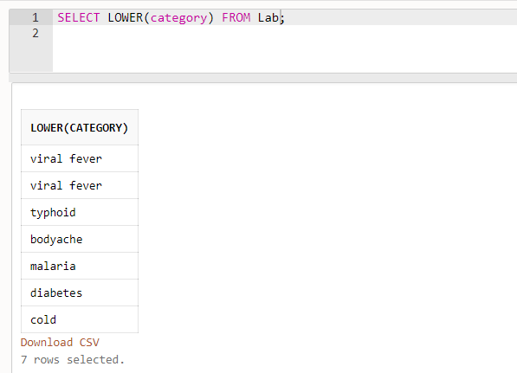

2) Select Upper(category) From Lab;

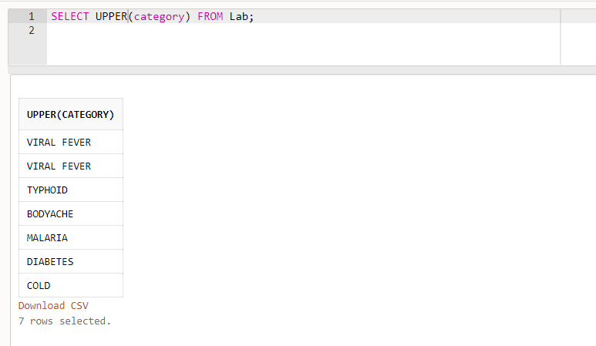

3) Select LRIM (Labno,’L’) From Lab;

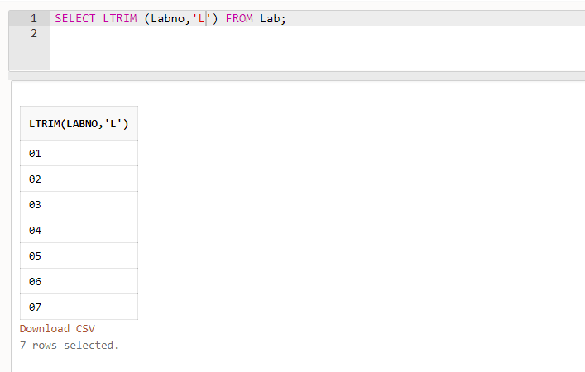

**GROUP FUNCTION:**

i)SELECT MAX(advance), MIN(advance) FROM INPATIENT;

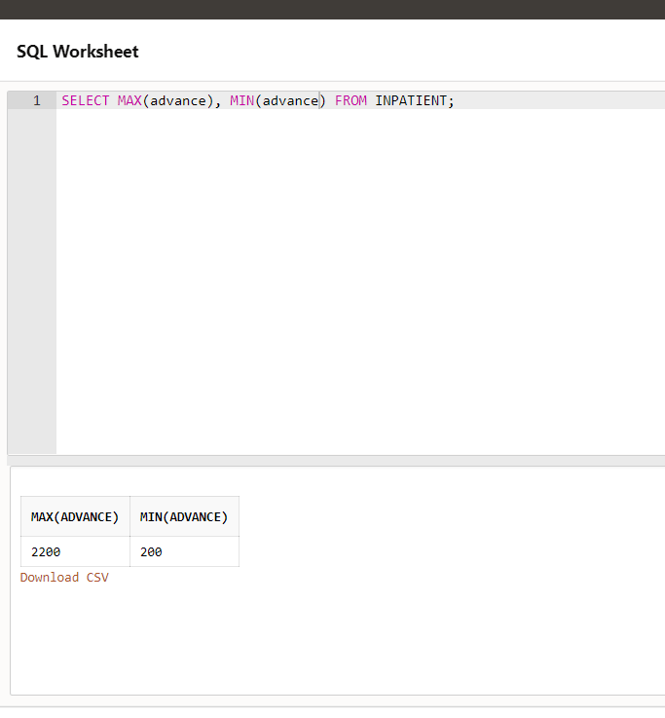

ii)SELECT pid,room_no FROM INPATIENT WHERE advance=4

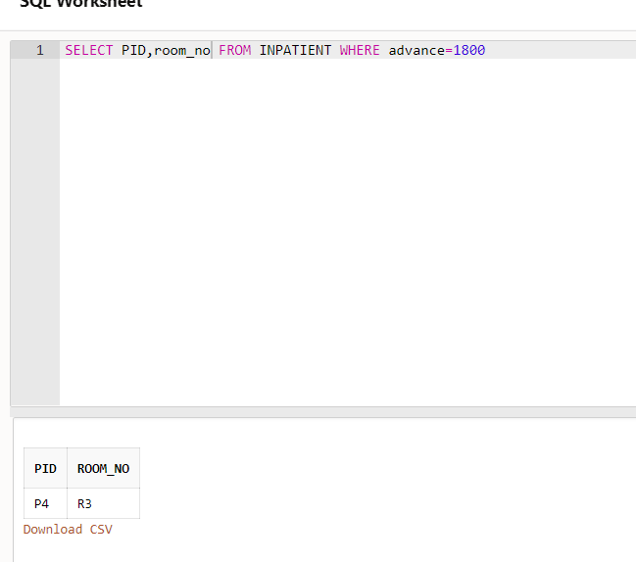

iii) SELECT pid,room_no,dt_of_adm FROM INPATEINT WHERE advance IS NOT NULL

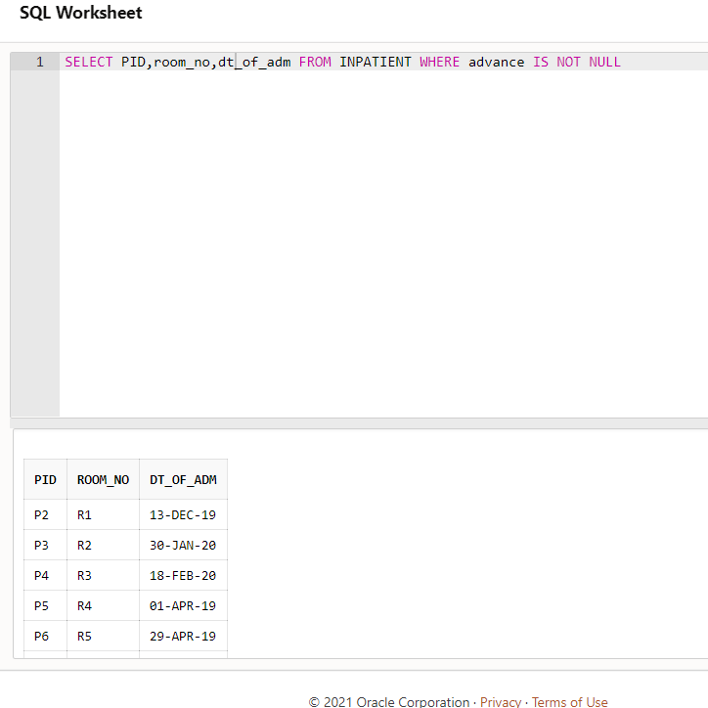

**Join:**

CREATE TABLE PATIENT_Database_one(PID varchar(5) NOT NULL PRIMARY KEY,NAME varchar(20) NOT NULL,AGE INT NOT NULL,WEIGHT INT NOT NULL,GENDER varchar(50) NOT NULL,ADDRESS varchar(50) NOT NULL,PHONENO INT NOT NULL,DISEASE VARCHAR(20) NOT NULL, DOCTORID VARCHAR(5) NOT NULL);

INSERT INTO PATIENT_Database_one VALUES('P2','AMAYA',28,50,'FEMALE','P123MAINROAD',8954356434,'VIRAL FEVER','D2');

INSERT INTO PATIENT_Database_one VALUES('P3','SAHIL',53,75,'MALE','BTM',9165095784,'VIRAL FEVER','D2');

INSERT INTO PATIENT_Database_one VALUES('P4','SAMARTH',15,35,'MALE','J212',8171507245,'TYPHOID','D3');

INSERT INTO PATIENT_Database_one VALUES('P5','SHARAN',29,65,'MALE','T12',9412964465,'BODYACHE','D4');

CREATE TABLE PATIENT_Database_two(PID varchar(5) NOT NULL PRIMARY KEY,NAME varchar(20) NOT NULL,AGE INT NOT NULL,WEIGHT INT NOT NULL,GENDER varchar(50) NOT NULL,ADDRESS varchar(50) NOT NULL,PHONENO INT NOT NULL,DISEASE VARCHAR(20) NOT NULL, DOCTORID VARCHAR(5) NOT NULL);

INSERT INTO PATIENT_Database_two VALUES('P4','SAMARTH',15,35,'MALE','J212',8171507245,'TYPHOID','D3');

INSERT INTO PATIENT_Database_two VALUES('P5','SHARAN',29,65,'MALE','T12',9412964465,'BODYACHE','D4');

INSERT INTO PATIENT_Database_two VALUES('P6','ANANYA',59,48,'FEMALE','ESTANCIA',8194034567,'MALARIA','D5');

INSERT INTO PATIENT_Database_two VALUES('P7','MANSI',34,56,'FEMALE','ABODEVALLEY',9410586268,'DIABETES','D6');

INSERT INTO PATIENT_Database_two VALUES('P8','MANAN',20,63,'MALE','ESTANCIA',8194032998,'COLD','D1');

1. Select PATIENT_Database_one.name, PATIENT_Database_one.PID from PATIENT_Database_one inner join PATIENT_Database_two on PATIENT_Database_one.PID=PATIENT_Database_two.PID;

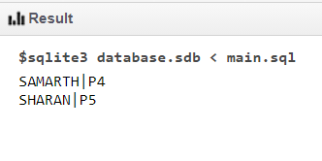

1. Select PATIENT_Database_one.name, PATIENT_Database_one.PID from PATIENT_Database_one left join PATIENT_Database_two on PATIENT_Database_one.PID=PATIENT_Database_two.PID;

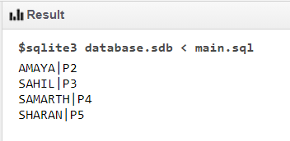

**Pl/SQL**

**Control Structure,functions and Iterative:**

SQL> set serveroutput on;

SQL> DECLARE

  2  A NUMBER;

  3  B NUMBER;

  4  C NUMBER;

  5  BEGIN

  6  A:=&A;

  7  B:=&B;

  8  C:=A+B;

  9  DBMS_OUTPUT.PUT_LINE('SUM OF '|| A ||' AND '|| B ||' IS '||C);

 10  END;

 11  /

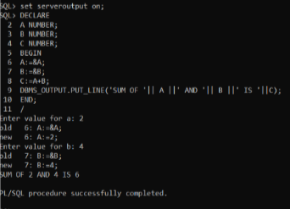

**Trigger and Cursor:**

1. Write a trigger to count number of new tuples inserted using each insert statement.

Create or Replace Trigger trg

BEFORE INSERT

ON OUTPATIENT

FOR EACH ROW

DECLARE

val number;

BEGIN

SELECT COUNT(*)

INTO val

FROM OUTPATIENT;

DBMS_OUTPUT.PUT_LINE('TABLE COUNT BEFORE INSERT = '||val);

END;/

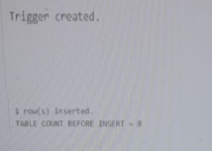

**View:**

1)CREATE view PATIENT_VIEW as SELECT * FROM PATIENT;

INSERT INTO PATIENT_VIEW VALUES('P9','ANAY',12,34,'MALE','P11MAINROAD',8954322434,'BACKACHE','D5');

INSERT INTO PATIENT_VIEW VALUES('P10','MOHIT',78,49,'MALE','S23M',89543561256,'COLD','D3');

SELECT * FROM PATIENT_VIEW ;

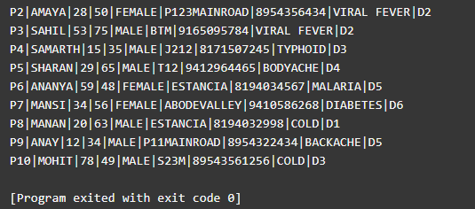

2) DELETE FROM PATIENT_VIEW WHERE DISEASE='MALARIA';

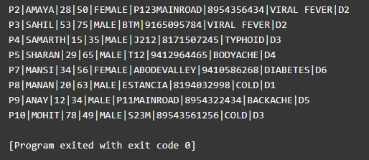

3) UPDATE PATIENT_VIEW set PID=4 WHERE DOCTORID='D6';

